How to Import DevOps Project Framework Using Excel

- Verify Team Foundations Server Office Integration is installed - https://visualstudio.microsoft.com/downloads#team-foundation-server-office-integration-2017
- Verify you have permissions to connect to the DevOps org
- Open Excel, click the Team tab
- Click New List
- Add the TFS server (DevOps org)
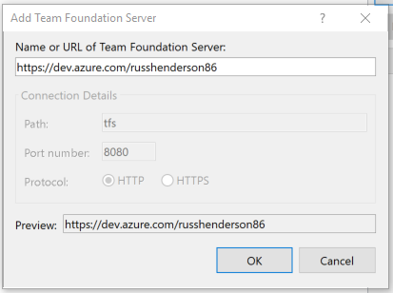
- Select the project and click connect
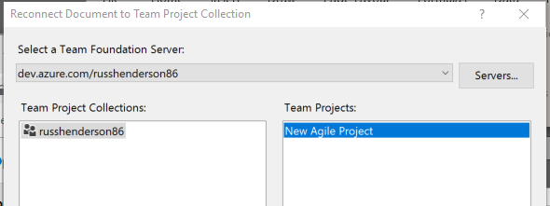
- Click New List, then Input List
- Click the Team tab, then Add Tree Level
- Click Convert to convert the list into a Parent-Child tree list
- Click Add Tree Level two more times, there should be 4 levels now
- Click in the spreadsheet, then click Choose Columns
- Add any additional columns, such as Description, Due Date, etc.
- The spreadsheet setup should now match the framework template
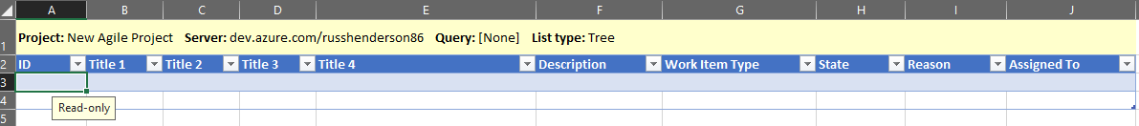

- Copy and paste the framework template into the spreadsheet
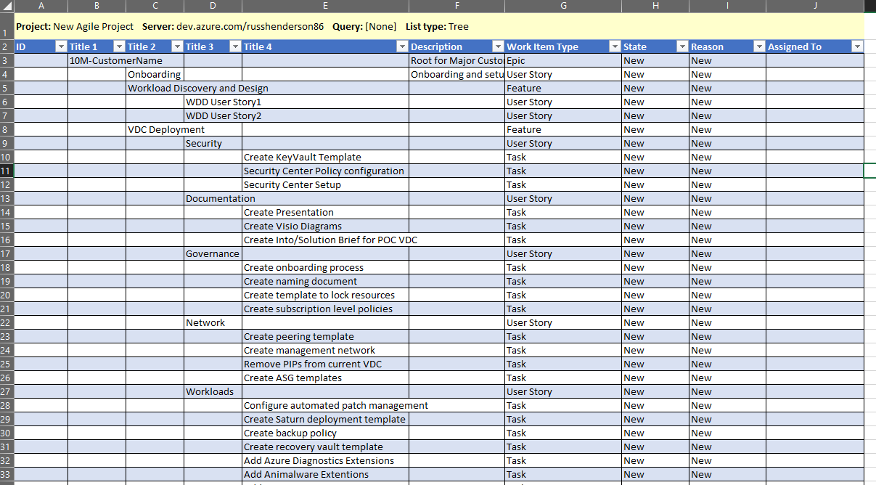
- Make any necessary changes
- Click a cell in the spreadsheet, then click Publish to lay down the structure in the DevOps project
- You should see your items get created in DevOps
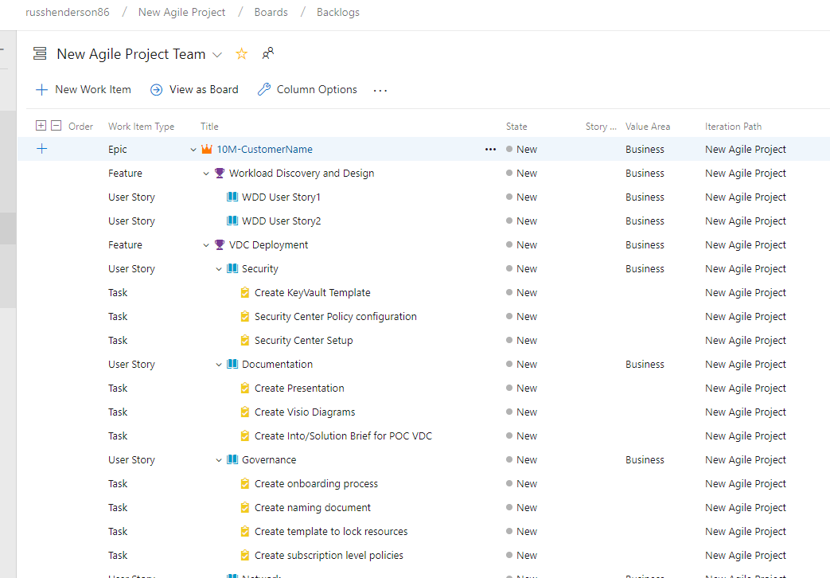
Appendix

References and additional information
https://docs.microsoft.com/en-us/azure/devops/boards/backlogs/office/bulk-add-modify-work-items-excel?toc=/azure/devops/boards/backlogs/toc.json&bc=/azure/devops/boards/backlogs/breadcrumb/toc.json&view=tfs-2018

